2. What is the difference between cat and more command?
- both commands `cat` and `more` displays file contents but If the file is large the contents scroll off the screen before we view it. So, command 'more' is like a pager which displays the contents page by page.
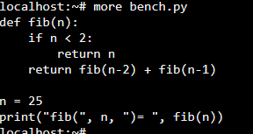
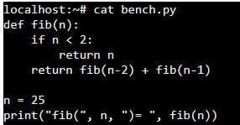
Both here are showing the same output because the content is not large to scroll.

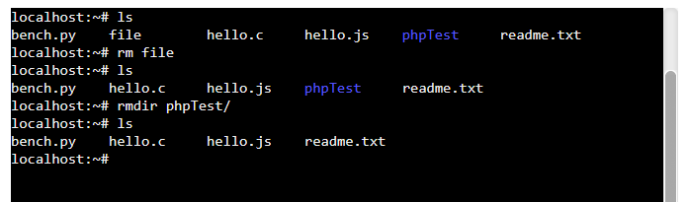
3. What is the difference between rm and rmdir using man?

- `rm` command can remove a file but the `rmdir` can remove empty directory. `man rm` and `man rmdir` will give me the manual of this command.

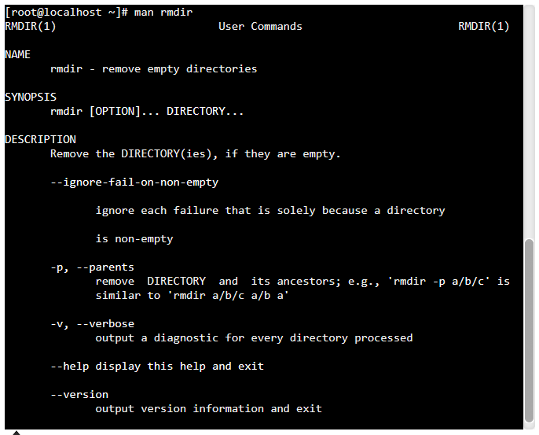
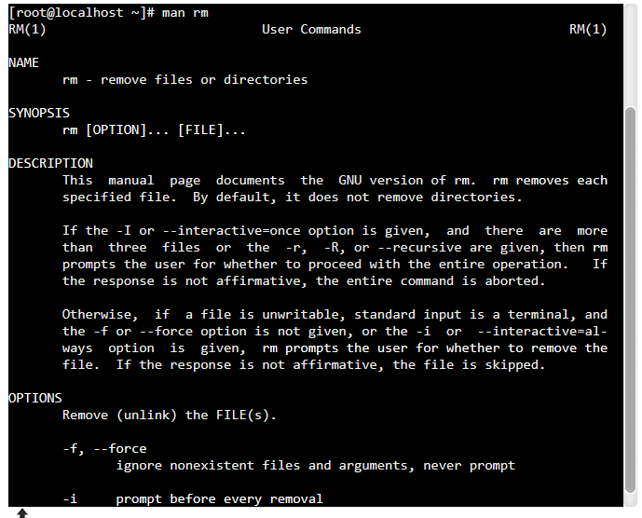
4. Create the following hierarchy under your home directory:

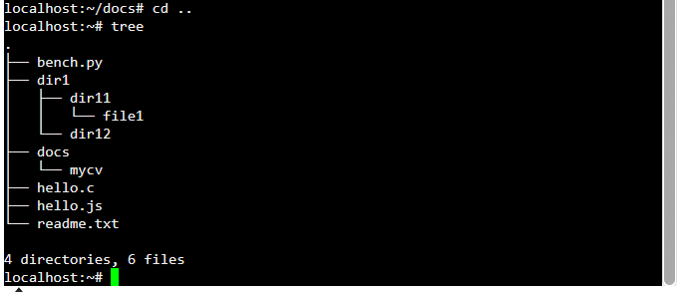
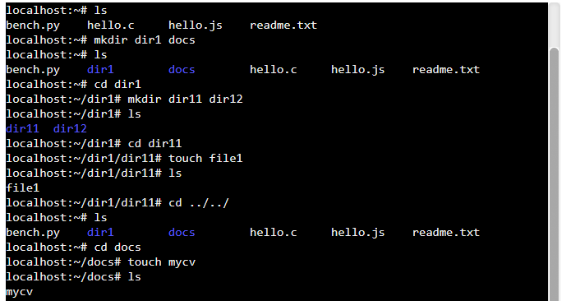

4(a):
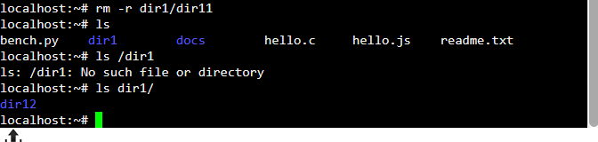
when trying to remove the folder with `rmdir` it thorws an error because the folder isn’t empty so we can remove it using `rm -r filename` and `-r` command option to recursively remove directory & its contents.

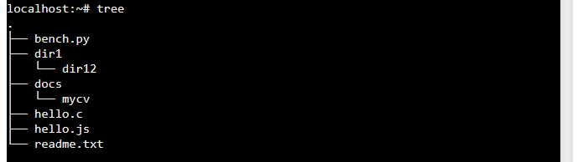
4(b):

With `rmdir -p dir1/dir12` it removes the nested directory structure.

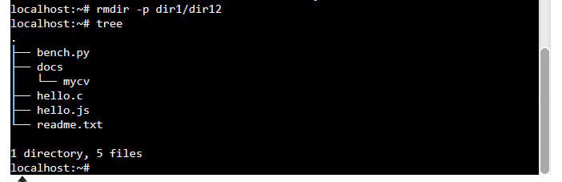
4(c):
- abs. path
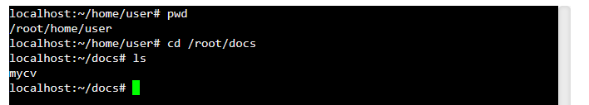
- relative path

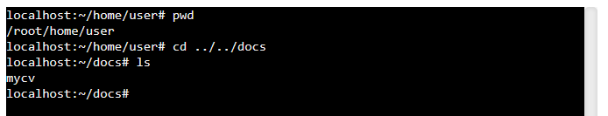

5. Copy the /etc/passwd file to your home directory making its name is mypasswd.
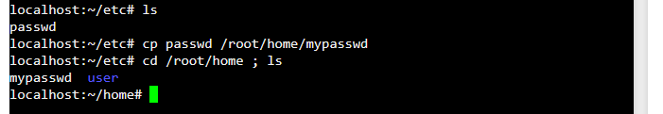
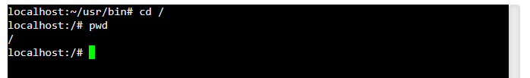
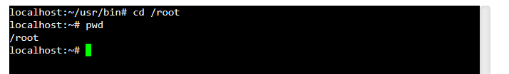
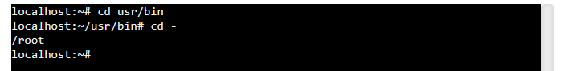
7. You are in /usr/bin, list four ways to go to your home directory
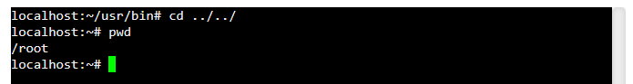
9. Display the first 4 lines of /etc/passwd
- `head -4 passwd`
10.Display the last 7 lines of /etc/passwd
11.Display the man pages of passwd the command and the file sequentially in one command.
`man passwd ; man /etc/passwd`
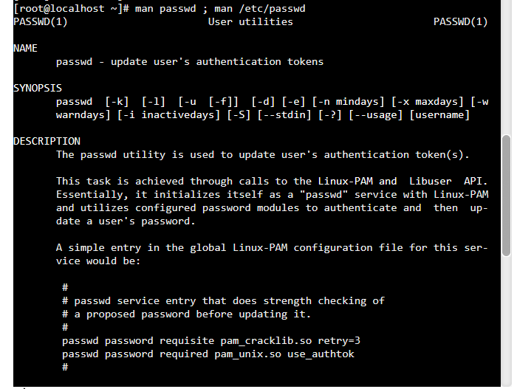

12.Display the man page of the passwd file.

- `man passwd`

13.Display a list of all the commands that contain the keyword passwd in their man page.

- man -k passwd

